**PRACTICAL NO – 2**

1. **CREATING ACCOUNT:**

STEP 1 : Enter all the required details

2)STEP 2: Verify the account

3) STEP 3 : verify your email account it will receive a link to join

4)SET 4 : The link will be send on the email and click on the link

**B)CREATING REPOSITORY :**

1)STEP 1 : Click on create repository

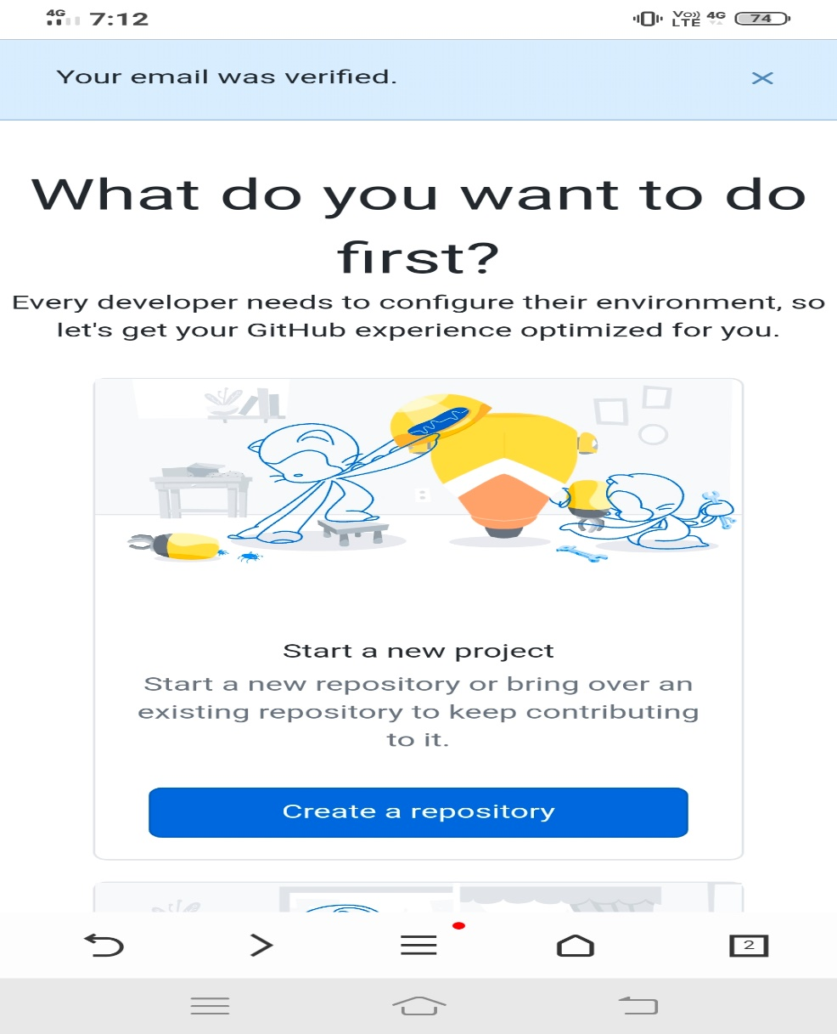

2) STEP 2 : Write your repository name and make it to public

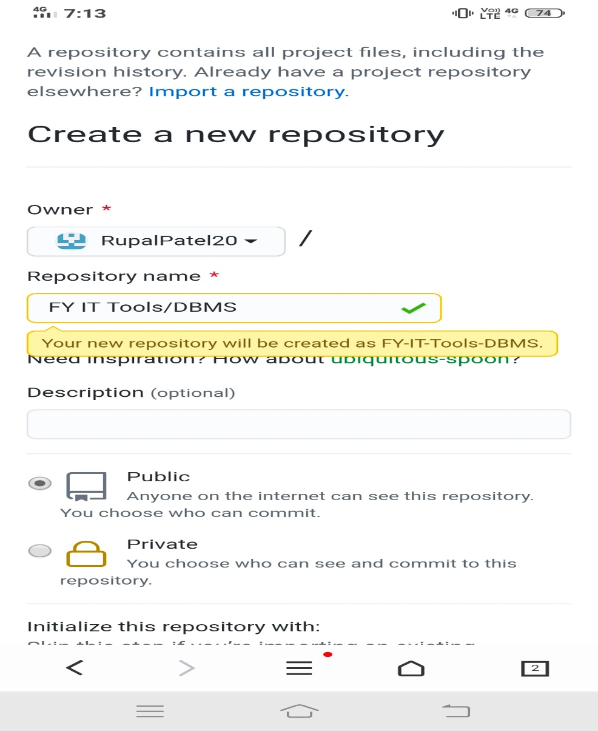

3) STEP 3 : click to readme file and click on create repository

4) STEP 4 : your repository has been created

**C)CLONING REPOSITORY :**

STEP 1 : Click on the code and copy the repository through HTTPS and paste it to your file to clone.

